

SCHOOL HOLIDAY FUN!
BALLON ARTIST

FREE FACE PAINTING

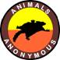
ANIMALS ON DISPLAY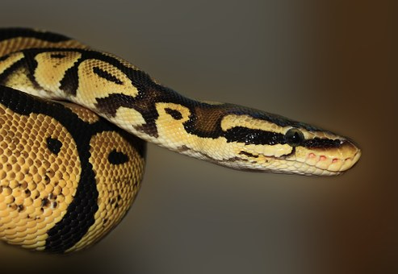 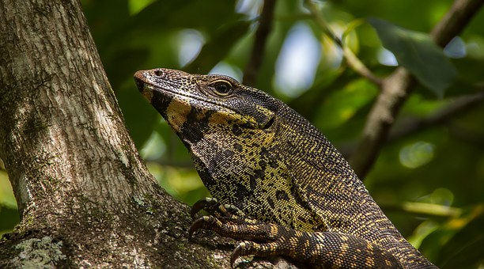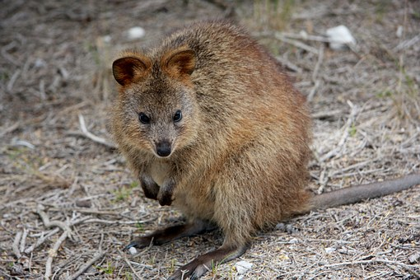 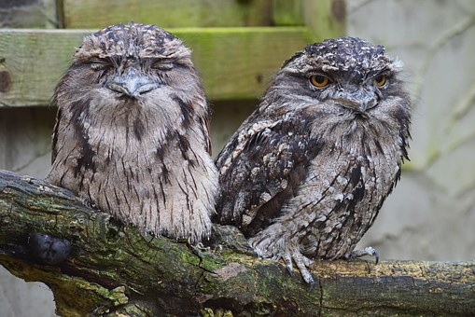
TUESDAY 24TH APRIL
10:30am – 1:30pm

